<!--This file created 2:29 PM 10/29/97 by Claris Home Page version 2.0-->11.4 Project
Numerical Computation of Logarithms

This project in the textbook addresses the dilemma you face if you're stranded for life on a deserted island with only a very basic calculator that does not calculate transcendental functions. Obviously your first priority is to get modern science going on this miserable island. Realizing their central importance for scientific computation, you decide to use power series to calculate tables of values of logarithms. Here we'll allow ourselves to employ modern technology itself, but we observe the spirit of the situation described by using only the four arithmetical operations 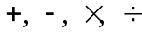 as we carry out the necessary approximate summation of series.

Our approach is based on the series

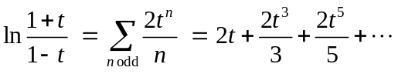 (1)

of Problem 58 in Section 11.4 of the textbook. This series converges if 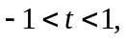 and converges rapidly enough to be useful if t is reasonably close to 0. Given a positive number x whose natural logarithm we want to compute, we first set

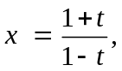 (2)
and then solve for
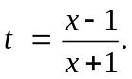 (3)

We can then substitute this value of t into the series in (1) in order to calculate ln x. The graph
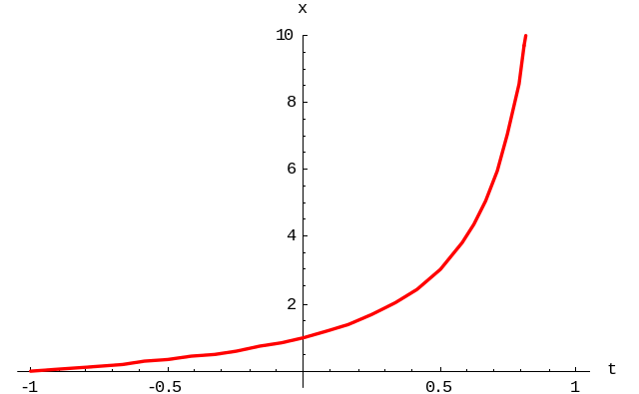

of (2) indicates that every positive value of x corresponds to some t-value in the interval 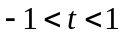 of convergence. Moreover, we see that values of x between 1 and 2 correspond to values of t between 0 and 1/ 3 (why), for which the convergence in (1) is fairly rapid.

If we use the series in (1) just to calculate the natural logarithms of the numbers 3/2, 5/4, 7/4, and 2, then we can apply the logarithmic relations

ln 3 = ln(3/2) + ln 2
ln 4 = 2 ln 2
ln 5 = ln(5/4) + ln 4
ln 6 = ln 2 + ln 3
ln 7 = ln(7/4) + ln 4
ln 8 = 3 ln 2
ln 9 = 2 ln 3
ln 10 = ln 2 + ln 5

to quickly complete a brief table of natural logarithms of the integers from 1 to 10. From here on it's just a matter of persistence to calculate all the logarithms we need.

The mechanics of summing series (1) will be discussed in the specific technology sections for this project.

Using a Graphing Calculator

Suppose we have a TI graphing calculator on our deserted island, but its built-in transcendental functions — including log(x) — are for some reason disabled. We therefore want to reconstruct these functions using only the four arithmetical operations 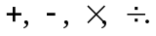 According to Eqs. (1)–(3) above, we can find ln x by summing the series

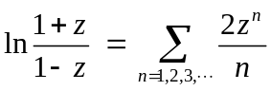

with z = (x–1)/(x+1). The key to summing this series is to note the transition from the typical term
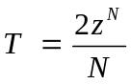
to the next term

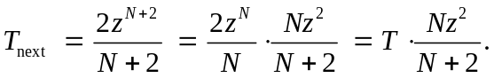

Given x, the commands

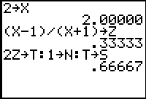

store x and calculate the corresponding value of z, then store

- the initial term T = 2 z in the series above,
- then initial index (or exponent) N = 1, and
- the initial sum S = T.

With each press of the Enter key, the multi-line command

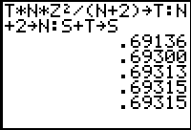

- uses the rule of transition above to calculate the next term in the series,
- increments the index by 2 to prepare for the next step, and
- adds the new term to the old sum to obtain the new sum.

We see that after adding 5 or 6 terms we have ln 2 = 0.69315 accurate to 5 decimal places.

The following TI-83 program NLOG automates this procedure, continuing to add each series term that exceeds 10⁻¹⁰ in absolute value (so as to calculate ln x accurate to 9 decimal places).

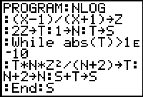

(We use NLOG because the names LN and LOG are reserved by the calculator for its built-in natural and base 10 logarithms, respectively.) For instance —

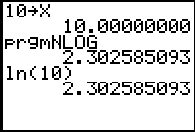

— so it looks like all is well. We can now proceed to calculate all the natural logarithms we wish, one at a time.

Alternatively, the FOR-loop in the following TI-83 calculator program automatically constructs a list of logarithms for us.

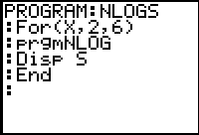

Thus we calculate quickly the logarithms of the numbers 2 through 6, and can edit the first line of NLOGS to calculate similarly whatever list of logarithms we wish.

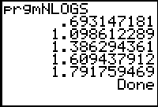

Using Maple

Suppose we have a computer and a copy of Maple on our deserted island, but its built-in transcendental functions — including log(x) — are for some reason disabled. We therefore want to reconstruct these functions using only the four arithmetical operations The key to summing the series in (1) is to note the transition from the typical term
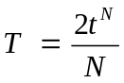
to the next term

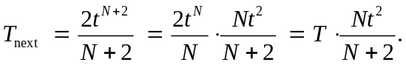

The following Maple procedure uses this rule of transition to sum the series in (1). It first calculates t = (x – 1)/(x + 1) as in (3), then starts the summation with

- the initial term T = 2t in series (1),
- the initial sum S = T, and
- then initial index (or exponent) N = 1.

Each step in the "while loop" then calculates and adds (to the preceding partial sum S) each successive new term T so long as it exceeds 10^{–10} in absolute value, and increments the index N by 2 to prepare for the next step.

nlog := proc(x)
local t, T, S, N;
t := (x-1)/(x+1);
T := 2*t;
S := T;
N := 1;
while abs(T) > 10^(-10) do
T := (T*N*t^2)/(N + 2);
S := S + T;
N := N + 2;
od;
S;
end;

(We use nlog because the names ln and log are reserved in Maple for natural and general logarithms, respectively.) For instance — inserting decimal points to get decimal rather than fractional results — we get

nlog(2.);
.6931471805

nlog(10.);

2.302585095

so it looks like all is well. Indeed, we can use Maple's map function to apply our nlog function to a whole column of x-values simultaneously, and thereby calculate our brief table of logarithms in one fell swoop.

x := [evalf(seq(i, i=1..10))];

x := [1., 2., 3., 4., 5., 6., 7., 8., 9., 10.]

v := map(nlog,x):
with(linalg):transpose([x,v]);
[1. 0 ]
[2. .6931471805]
[3. 1.098612288]
[4. 1.386294360]
[5. 1.609437911]
[6. 1.791759472]
[7. 1.945910149]
[8. 2.079441540]
[9. 2.197224577]
[10. 2.302585095]

Using Mathematica

Suppose we have a computer and a copy of Mathematica on our deserted island, but its built-in transcendental functions — including log(x) — are for some reason disabled. We therefore want to reconstruct these functions using only the four arithmetical operations The key to summing the series in (1) is to note the transition from the typical term
to the next term

The following Mathematica function uses this rule of transition to sum the series in (1). It first calculates t = (x – 1)/(x + 1) as in (3), then starts the summation with

- the initial term T = 2t in series (1),
- the initial sum S = T, and
- then initial index (or exponent) N = 1.

Each step in the "while loop" then calculates and adds (to the preceding partial sum S) each successive new term T so long as it exceeds 10^{–10} in absolute value, and increments the index N by 2 to prepare for the next step.

ln[x_] :=
Module[{t = (x - 1)/(x + 1), T, S, N},
T = 2*t;
S = T;
N = 1;
While[Abs[T] > 10^(-10),
T = (T*N*t^2)/(N + 2);
S = S + T;
N = N + 2];
S]

For instance — inserting decimal points to get decimal rather than fractional results — we get

ln[2.]
0.693147

ln[10.]
2.30259

so it looks like all is well. (Recall that Mathematica's own natural logarithm function is Log rather than ln.) Indeed, we can use Mathematica's Map function to apply our ln function to a whole column of x-values simultaneously, and thereby calculate our brief table of logarithms in one fell swoop.

X = Table[x, {x, 1, 10}] // N
{1., 2., 3., 4., 5., 6., 7., 8., 9., 10.}

Transpose[{X, Map[ln,X]}] // TableForm
1 0.
2. 0.693147
3. 1.09861
4. 1.38629
5. 1.60944
6. 1.79176
7. 1.94591
8. 2.07944
9. 2.19722
10. 2.30259

Using MATLAB

Suppose we have a computer and a copy of MATLAB on our deserted island, but its built-in transcendental functions — including log(x) — are for some reason disabled. We therefore want to reconstruct these functions using only the four arithmetical operations The key to summing the series in (1) is to note the transition from the typical term
to the next term

The MATLAB function below starts with

- the initial term T = 2t in series (1),
- the initial sum S = T, and
- then initial index (or exponent) N = 1.

Each step in the "while loop" then calculates and adds (to the preceding partial sum S) each successive new term T so long as it exceeds 10^{–10} in absolute value, and increments the index N by 2 to prepare for the next step.

function y = lnseries(t)
T = 2*t; % initial term
S = T; % initial sum
N = 1; % initial index
while max(abs(T)) > 1e-10
T = T.*t.*t*N/(N+2);
S = S + T;
N = N + 2;
end
y = S;

Before using this function to calculate ln x, we must first find t = (x – 1)/(x + 1) as in (3), then calculate lnseries(t). Thus our deserted island natural logarithm function is defined by

function y = ln(x)
t = (x-1)./(x+1);
y = lnseries(t);

For instance, we then get

ln(2)
ans = 0.6931

ln(10)
ans = 2.3026

so it looks like all is well. (Recall that MATLAB's own natural logarithm function is log rather than ln.) Indeed, because our lnseries and ln functions are "vectorized", we apply our ln function to a whole column of x-values simultaneously, and thereby calculate our brief table of logarithms in one fell swoop:

X = 1 : 10;
[X; ln(X)]'
ans =
1.0000 0
2.0000 0.6931
3.0000 1.0986
4.0000 1.3863
5.0000 1.6094
6.0000 1.7918
7.0000 1.9459
8.0000 2.0794
9.0000 2.1972
10.0000 2.3026

